**PRATIMA BHATTARAI**

**LAB-4**

1. What is the IP address of your computer?

The IP address of my computer is 192.168.0.29.

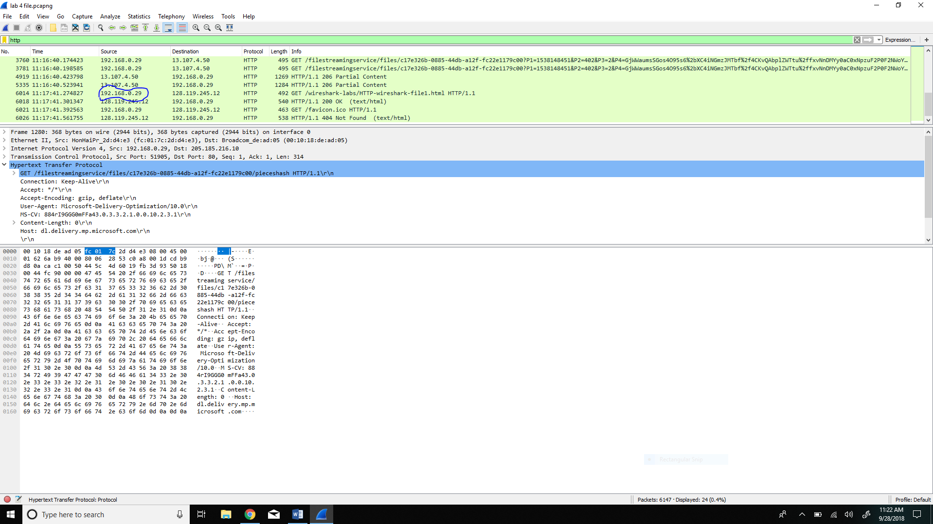

1. What is the total length of the datagram?

The total length of datagram is 478.

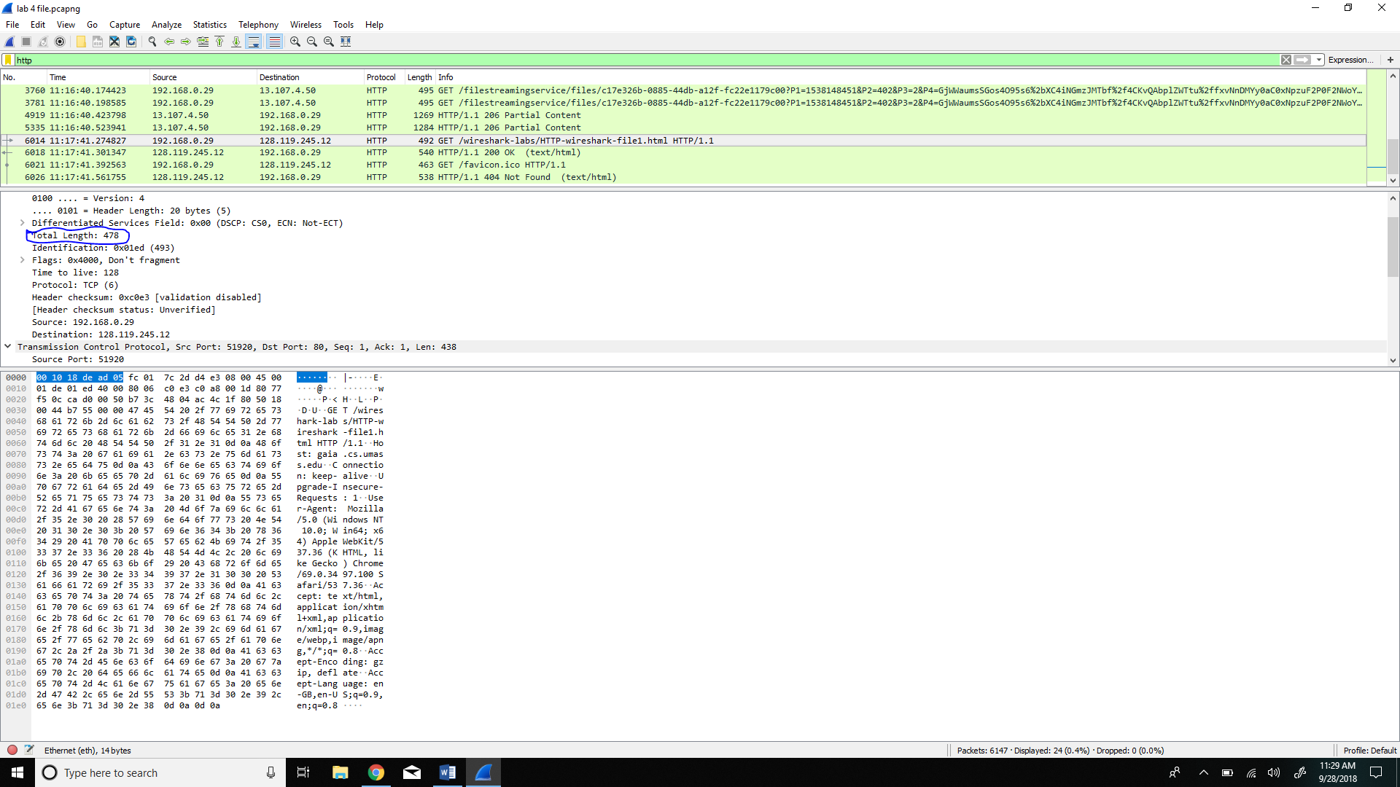

1. Has the IP datagram been fragmented?

No, the datagram has not been fragmented. 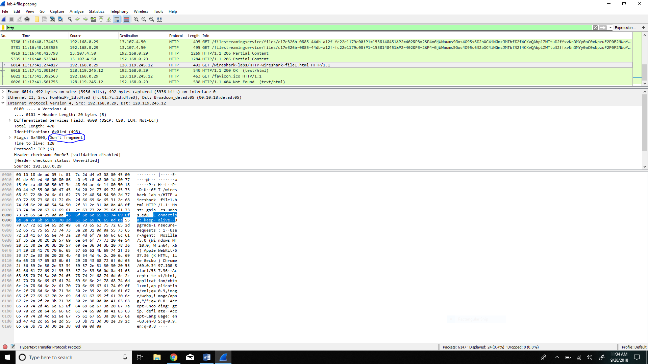

1. How many bytes are in the IP header?

20 bytes are there in the IP header.

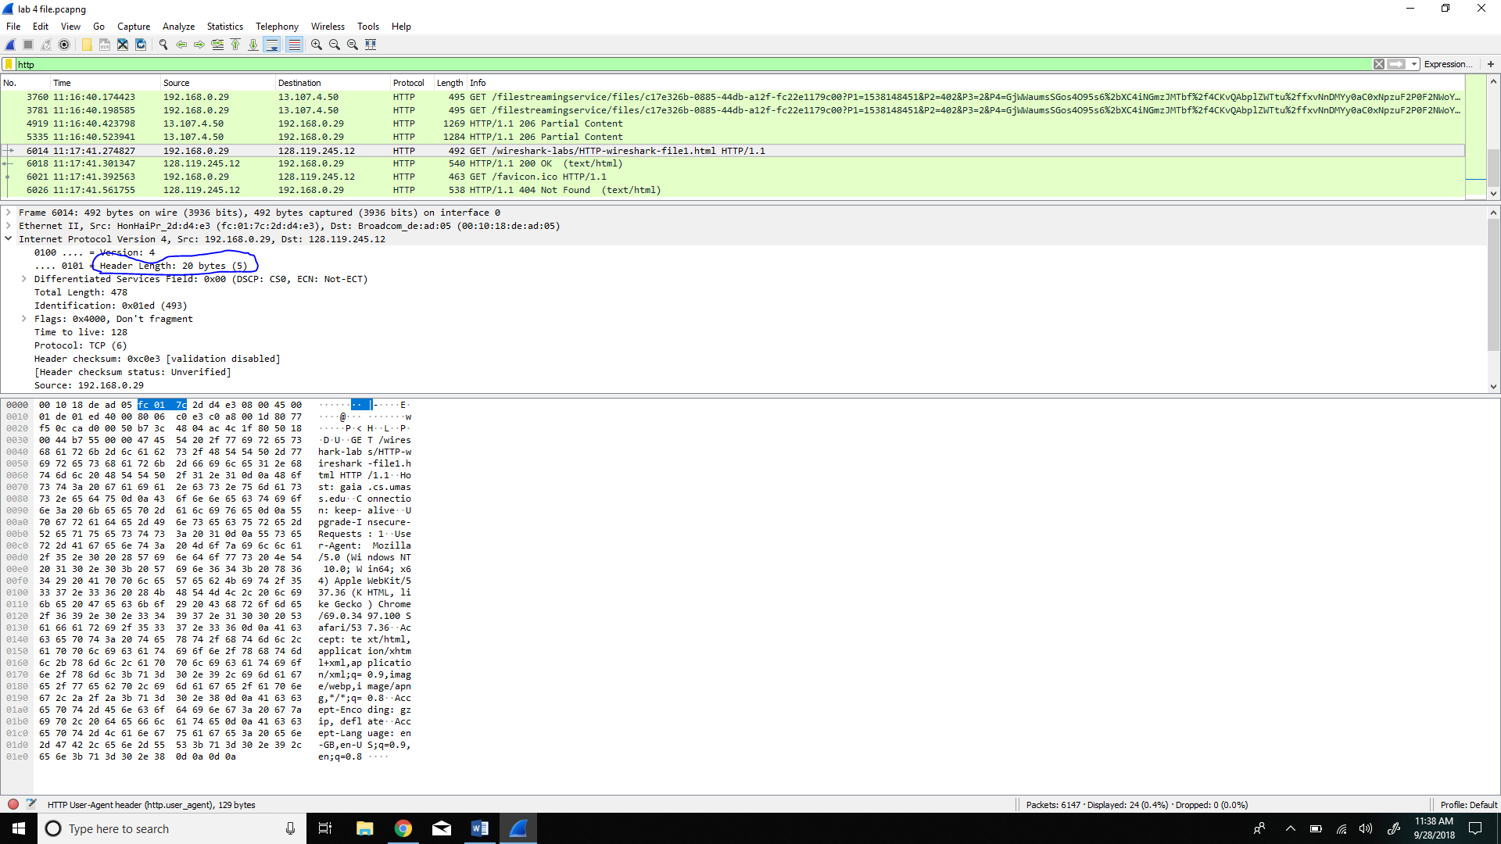

1. How many bytes are in the payload of the IP datagram?

There are 458 bytes in the payload of the IP datagram. The way I determined the number of payload is I deducted the IP header length from the total length of the datagram.The remained length of datagram that I got is the payload size.



The print of HTTP OK message is attached here.